How to Create and Share Documents On-Line

Start by creating your Google Drive account:

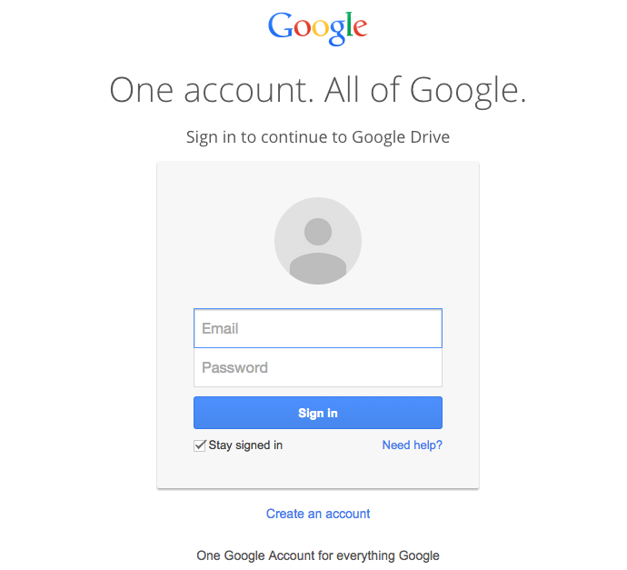
- Go to accounts.google.com

- Click on Create an account

- Fill in the required fields

- And you’re ready to go!

How to create a new file:

- From Google Drive, locate and select the New button, then choose the type of file you want to create. In our example, we'll select Google Docs to create a new document.

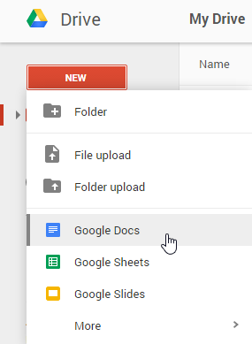

- Your new file will appear in a new tab on your browser. Locate and select Untitled document in the upper-left corner.
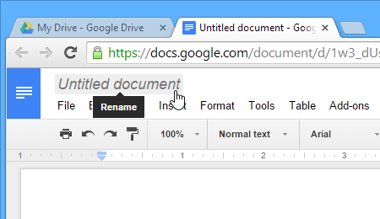

- The Rename dialog box will appear. Type a name for your file, then click OK.
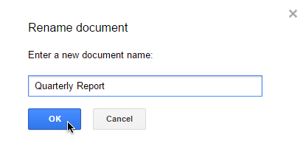

- Your file will be renamed. You can access the file at any time from your Google Drive, where it will be savedautomatically. Simply double-click to open the file again.

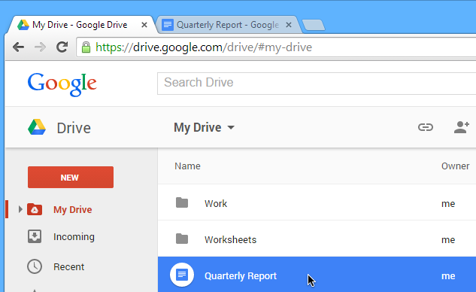

You may notice that there is no Save button for your files. This is because Google Drive uses autosave, which automatically and immediately saves your files as you edit them.
