Response Log

Book Title: ___________________________________________ Author: _________________

Getting Started

Examine the cover, read the title, back cover and the first page to make predictions about your novel.

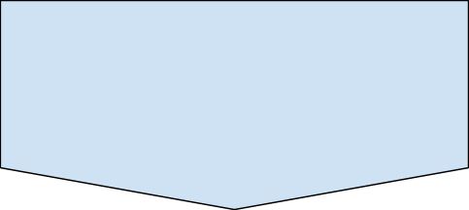
What makes you say this?

When and where does the story take place?

_______________________________________________________________________________________________________________________________________________________________________________________________________________________________________

Who is telling the story? _______________________________________________________

Main Characters

Use the table below to collect information and draw conclusions about the main characters in your novel.

Descriptions, actions, dialogue, thoughts, relationships... | What does this information tell you about the character?
Secondary Characters

- Make a list of secondary characters.
- Provide a brief description (physical or psychological description, relationship with main character, role etc.)

Name | Brief Description

Setting

- Time Period, Setting, Historical Details

Time - Describe when the story takes place.

How do you know this?

Place - Describe where the story takes place:

How do you know this?

Background Research

Make a list of topics, places, and historical events that you think are important in your novel.

- Choose one of the elements in your list above
- Use the Internet to research this topic, place, or historical event
- Note your findings

What does this information reveal about the story? (think about conflict, characters, atmosphere)

Plot
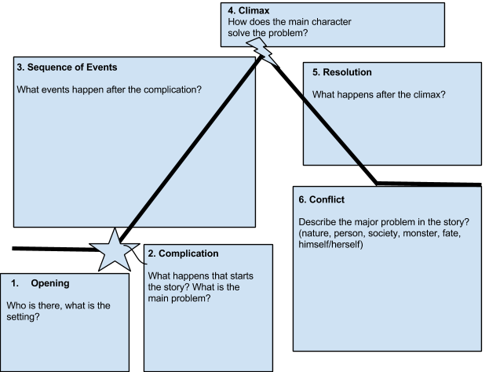
- Use this diagram to help you understand the action in your story. Note important details in the boxes.

What is the story about?

PLOT
- Use the information from the diagram on the previous page to complete the boxes below

1.

2.

3.

4.

5.

6.

Theme
I Read it, but I Don’t Get it!

- Use all the information you’ve gathered to draw conclusions about your story.
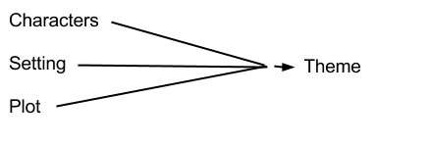
What’s important or interesting to me | Author’s message (What the author is trying to say about life, society, humanity)

